ADMIN (PHP) TESTING

1. First, you need to go to the homepage of Nature’s Fresh Mart and then you can find LOGIN button at the navigation bar.



1. Click on the LOGIN button and then fill in the form with admin login credentials.
2. Valid login credentials.

Username

**nfmadmin@gmail.com**

Password

Saugat123

(for testing purpose)

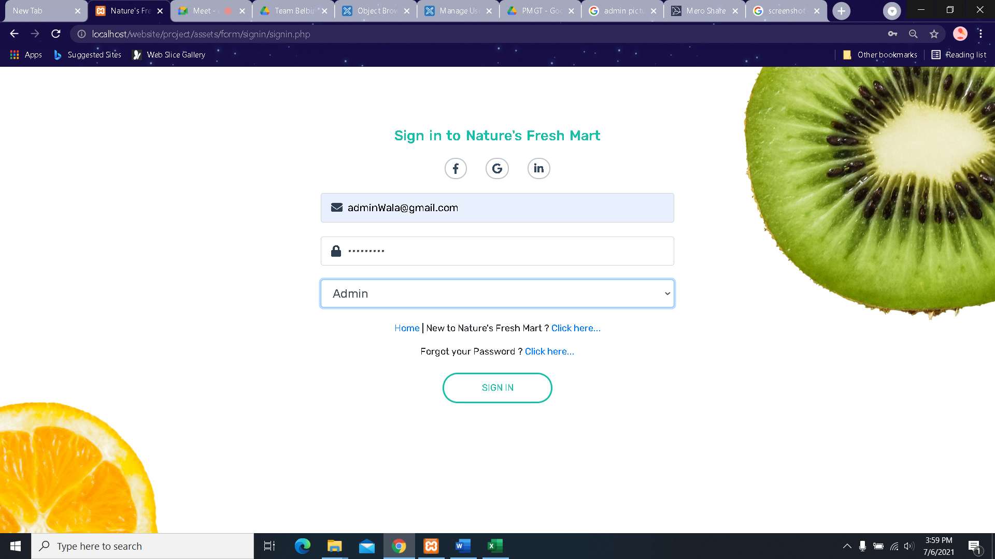

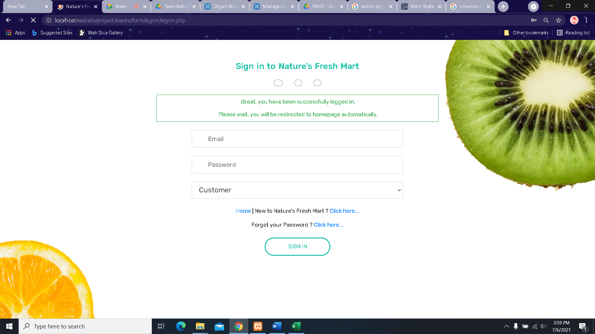

1. Invalid login credentials.

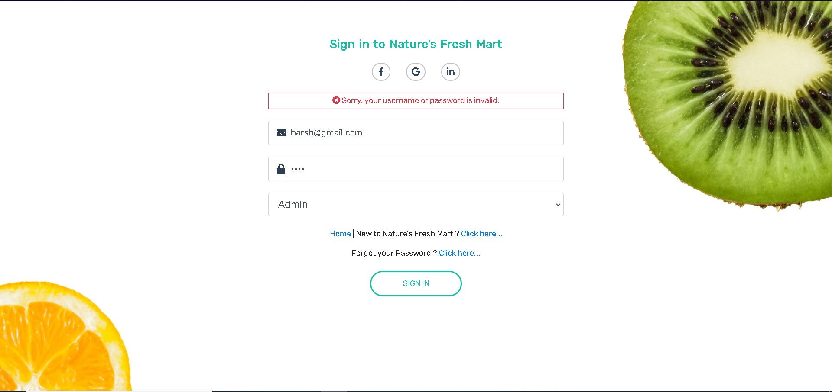

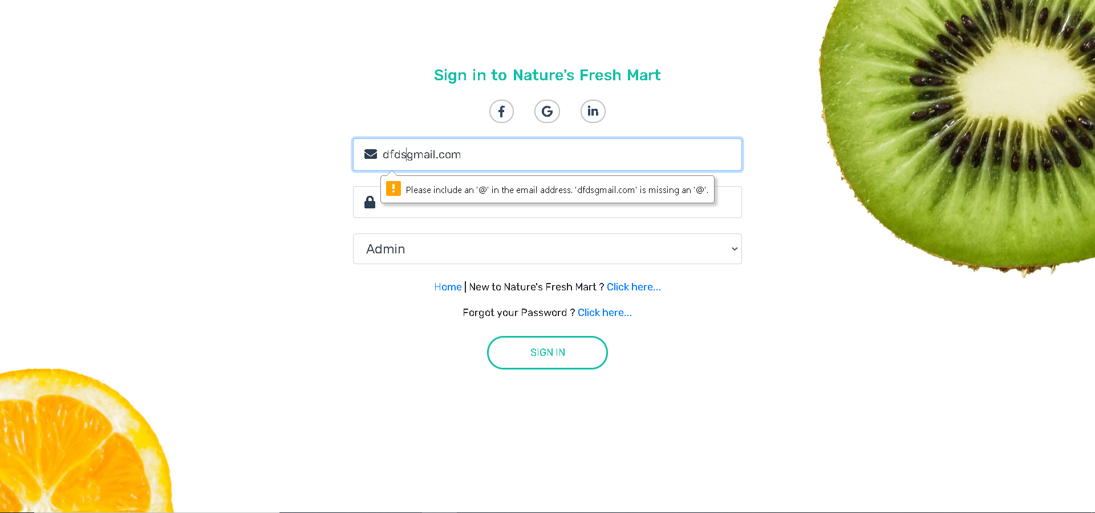

1. Empty field

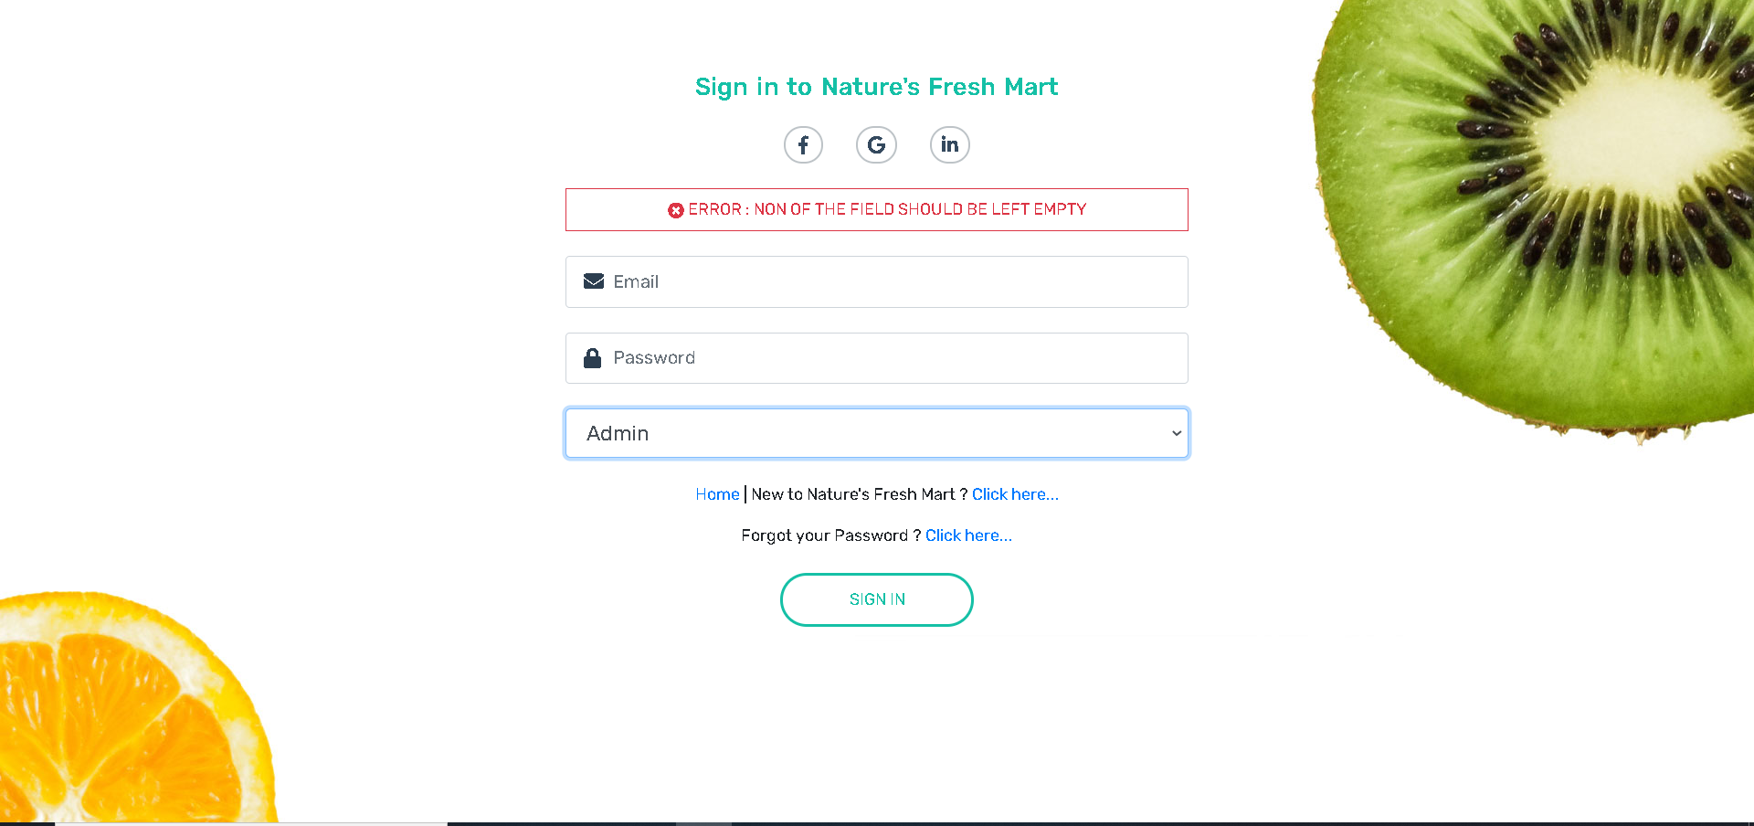

1. . After logged in, admin will be in homepage from where he/she will be able to go to admin panel(php)

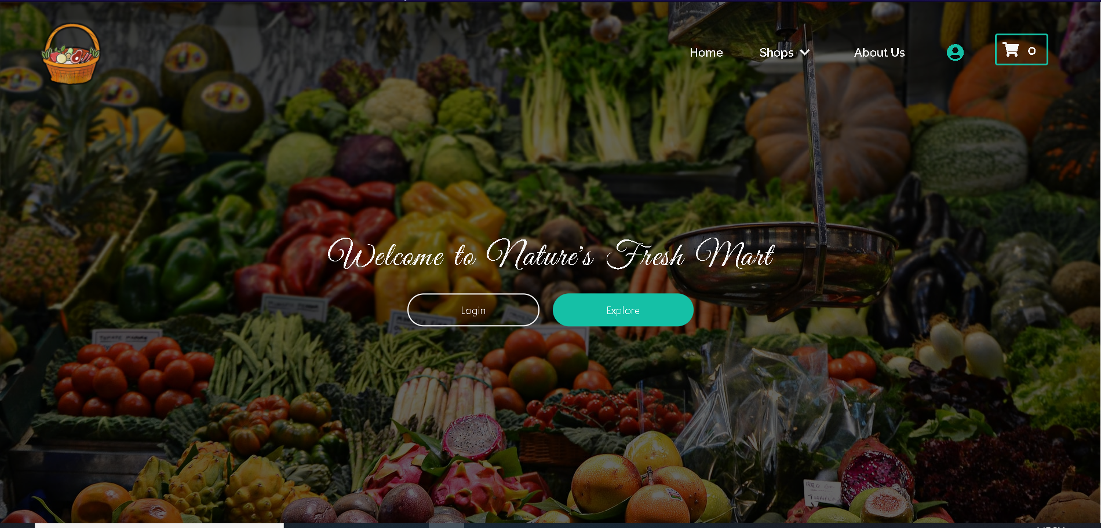

After clicking on Profile Icon in Homepage ADMIN_PANEL appears as below.

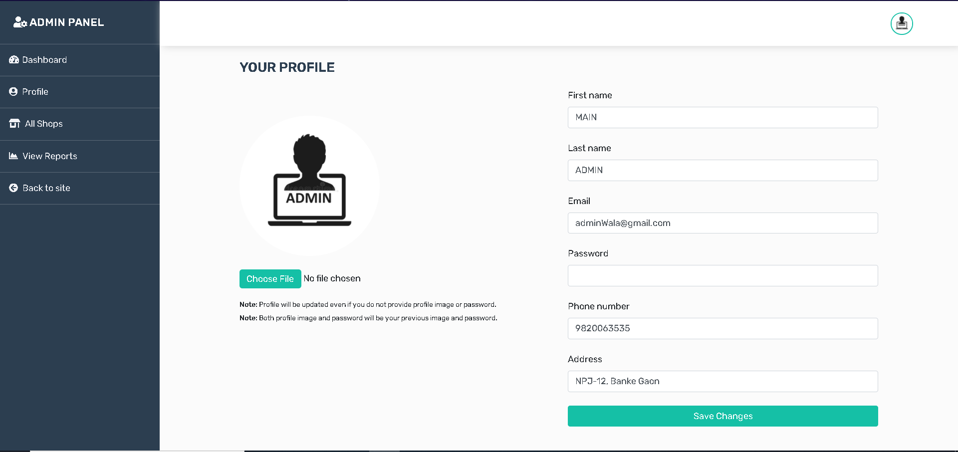

1. Admin can view their profile and make any changes if required as shown above.
2. Admin can view Dashboard where there will be all the customers list as shown below.

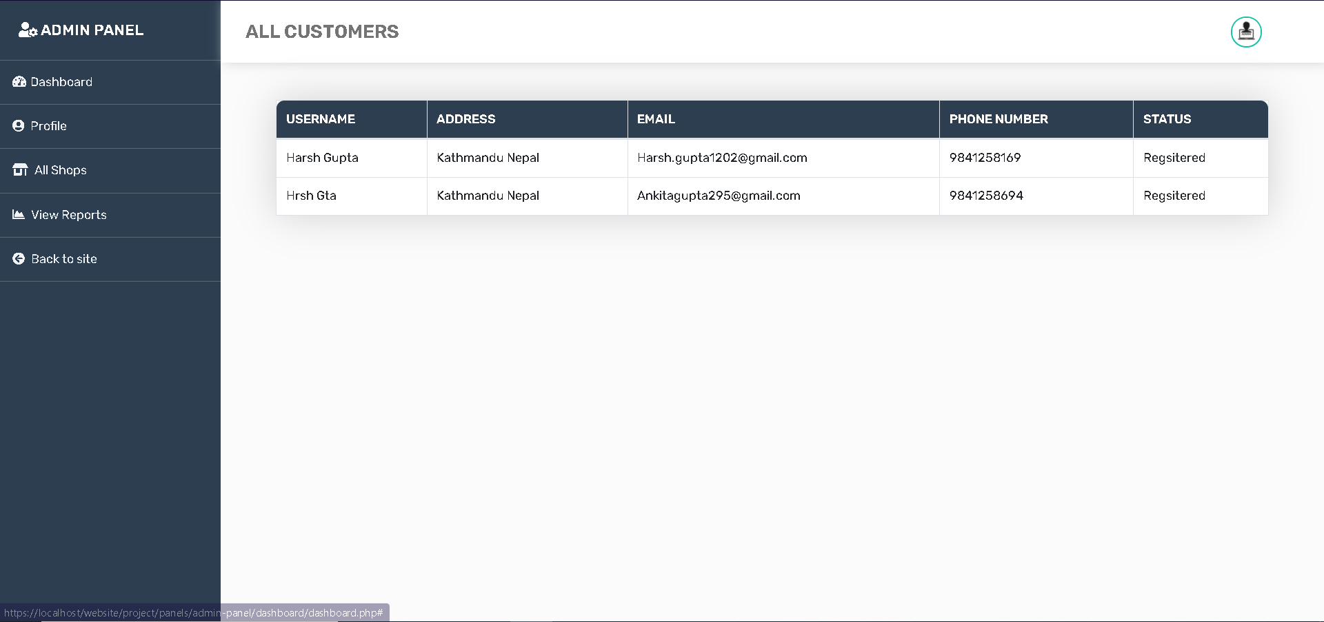

1. Admin also can go to ALL SHOPS button and ‘Login as Trader ‘for any trader

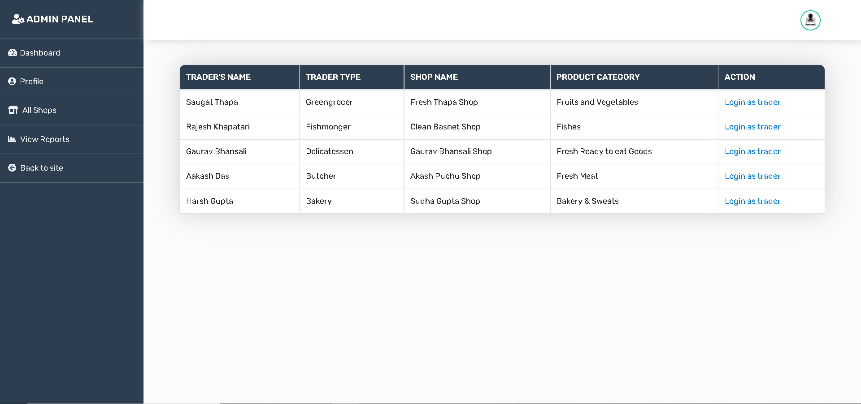

1. After Admin logs in as trader, he/she will be redirected to respective trader’s panel where admin can disable any product if it violates the Terms and Conditions

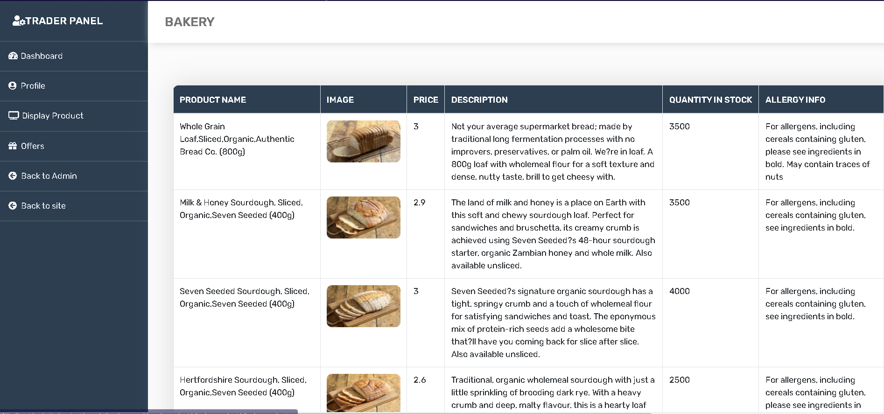

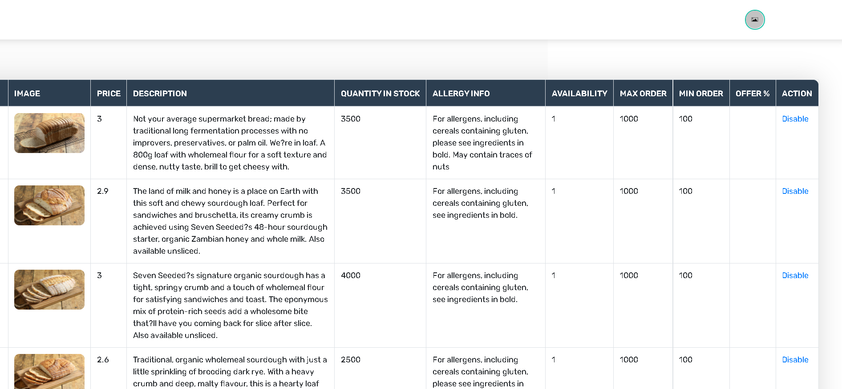

1. Product Disabled

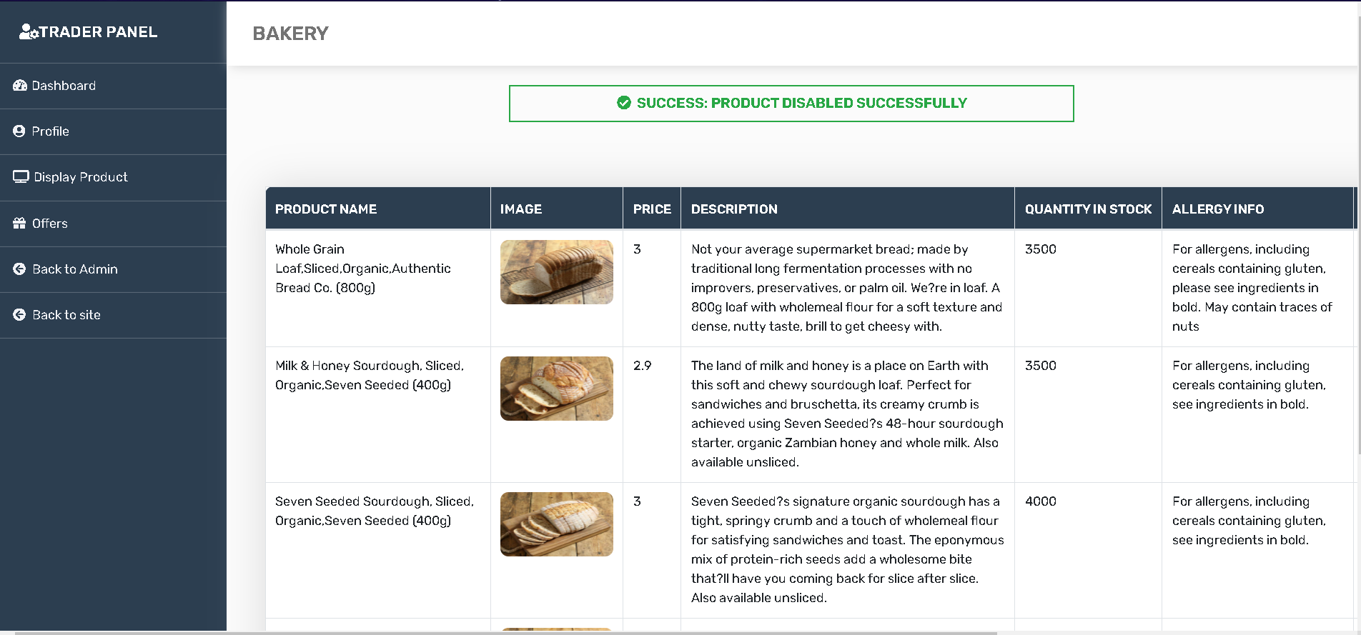

Note: If any product gets disabled then only trader will have only option to delete but not to update the product.

1. When Admin clicks the VIEW REPORTS in its PANEL, he/she will be directed to oracle apex login page where he/she will sign in

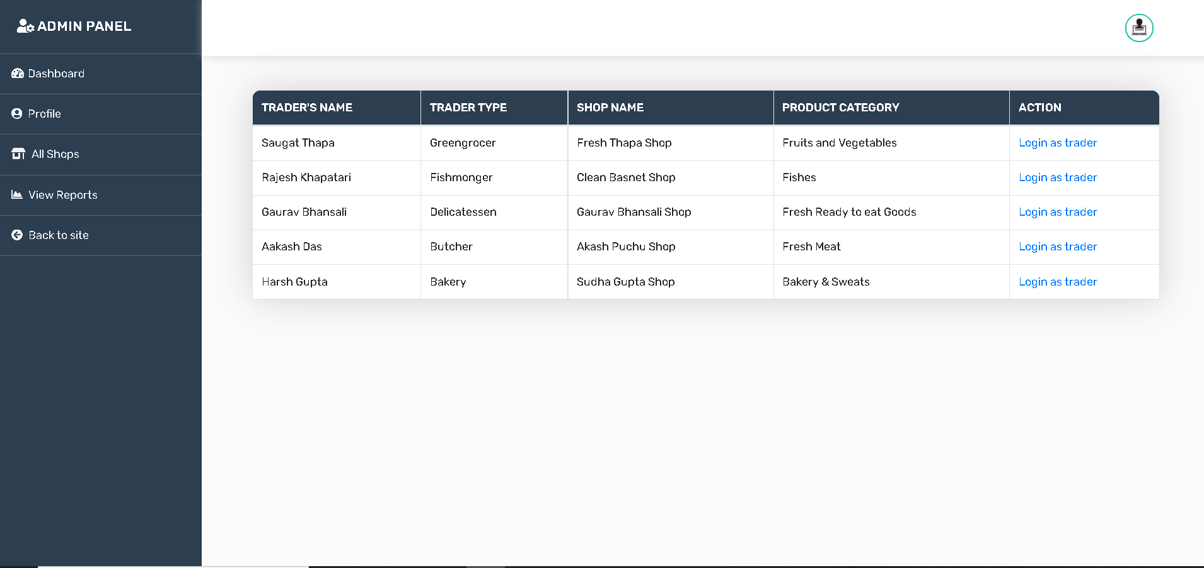

Directed to Oracle

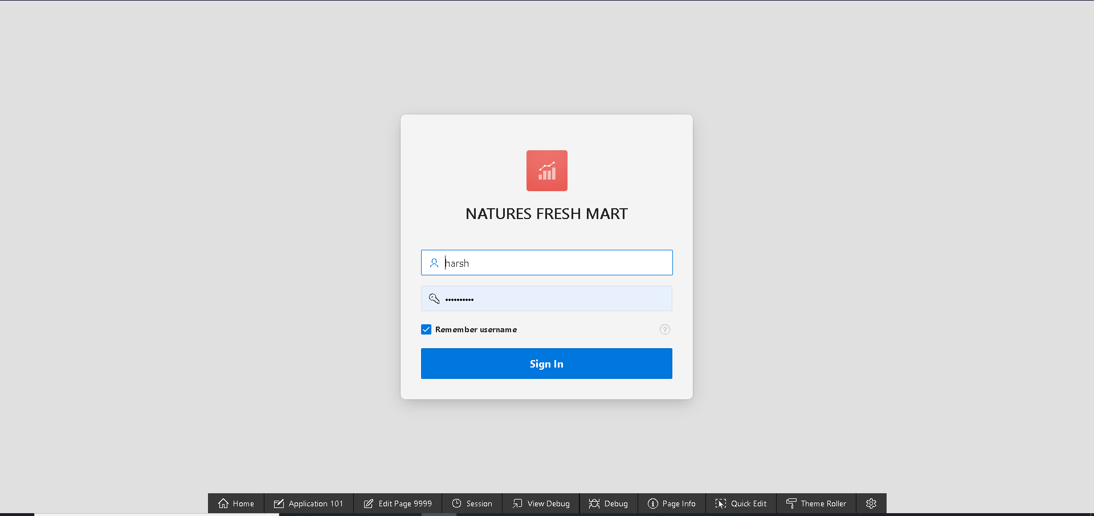

1. Logout

Admin can logout by clicking on the profile image on top side.

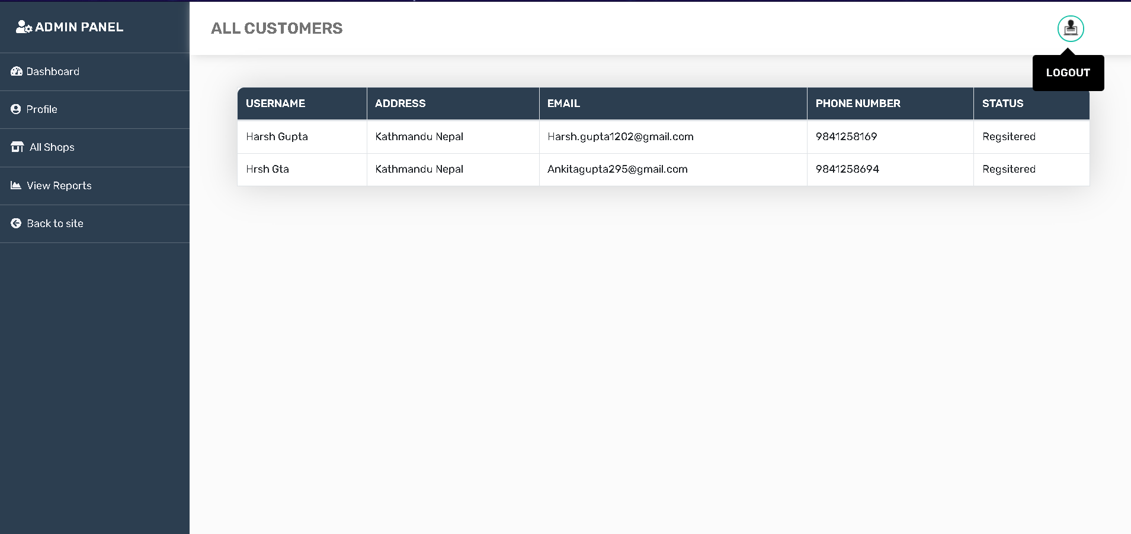

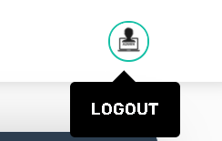

Admin will be redirected to homepage

